1. **ABSTRACT**

Today, it is very important to keep track of the records of employees currently working in the particular company or organization. In the past days, people were maintaining records of the employees manually. The task was very complicated and had maximum difficulties.

To overcome this problem, further, computer software’s are introduced. But most of software’s had attendance problem which should be correctly noted down. But these systems taking attendance of the employee while log in. It is the faulty system as anyone can give our password to other one and without being present, can mark the attendance.

To avoid this we used the system having attendance on the basis of finger print. It works better than previous system. So that is project.

1. **INTRODUCTION**

We developed such a project that deals with the concept of maintenance of employees of particular company or organization. The project makes use of the concept of object oriented programming structure of the java language. It also uses the ODBC tool with ms access database for the storage of the data. Further the software gets connected with a special finger printing device for the interaction. This device captures employee fingerprint, matches it within a database records, and accordingly notes the attendance. So in this way, our project keeps the track of working.

**2.1 Existing System:**

There is already a payroll system is existing but whatever we have made is little different from the existing one. The old system has number of problems in working especially while attendance issue occurs. Problems found in previous system are as follows.

* Fake attendance can’t be avoided.
* Everyone has to login while giving attendance without necessary.
* Less rights of access provided as compare to administrator.
* Little complicated.

**2.2 Proposed system:**

To overcome above problems, we proposed something newer in our system. We used a special finger printing device for the attendance. It can read finger prints of any employee at any time and stores all the database entries in the memory.

We managed the payment of all employees as per the attendance of them and the system gives the complete report of this with each and every parameters.

1. **SYSTEM REQUIREMENTS**

**Hardware Requirements:**

Processor : Intel-core

RAM : 256MB

Hard Disk : 40 GB

**Software Requirements:**

Windows XP and onwards…

Java Standard Development Kit 7

Microsoft Office 2007

**3.1 Project Environment**

JAVA STANDARD DEVELOPMENT KIT 7

The java SDK 7 is used by our team to develop our project. It is the most powerful tool to develop any kind of management type softwares. The applications made through this platform are fully compatible with most of the versions of windows operating system.

This platform provides facility to generate an executable jar file which is also called as java archive file which can be independently run onto any platform.

MICROSOFT OFFICE 2007

The ms office 2007 is used as the back end environment for the purpose of database. It provides tabular structure of saving data entries and gives permission to perform various operations.

1. **SYSTEM ANALYSIS**

IF ID AND PASSWORD AUTHORIZEDTHEN

false

true

MAIN HOME FORM

OR MDI

**Fig. 4.1 Login Process**

MAIN HOME FORM

OR MDI

**Fig. 4.2 MDI Form**

**Fig. 4.3 New Employee Details**

IF USER ID MATCHES THEN

match again

false

true

Salary

Name

Post

Address

J. Date

Email

Contact

**Fig. 4.4 Employee report**

**Fig. 4.5 Notice**

1. **SYSTEM DESIGN**

**Table name: 5.1 Employee Details**

|  |  |  |  |
| --- | --- | --- | --- |
| **SR** | **FIELD NAME** | **DATA TYPE** | **INPUT TYPE** |
| 1 | Emp_Id | Number | Primary Key |
| 2 | Emp_Name | Text | Not Null |
| 3 | Emp_Address | Text | Not Null |
| 4 | Emp_Contact | Text | Not Null |
| 5 | Emp_Mail | Text | Optional |
| 6 | Emp_Post | Text | Not Null |
| 7 | Emp_Sal | Number | Not Null |
| 8 | Emp_JDate | Date/Time | Not Null |

**Table Name: 5.2 Attendance Information**

|  |  |  |  |
| --- | --- | --- | --- |
| **SR** | **FIELD NAME** | **DATA TYPE** | **INPUT TYPE** |
| 1 | Emp_Id | Number | Primary Key |
| 2 | Dt | Date/Time | Not Null |

1. **PROJECT FORMS**

**Log In:**

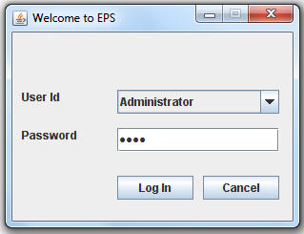

**MDI:**

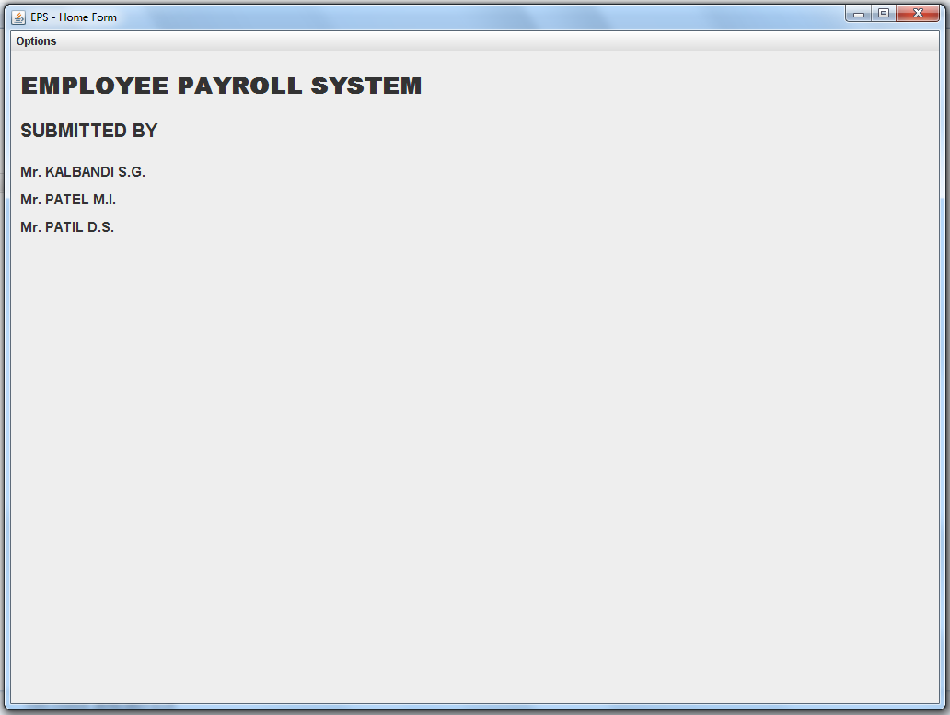

**New Employee Details:**

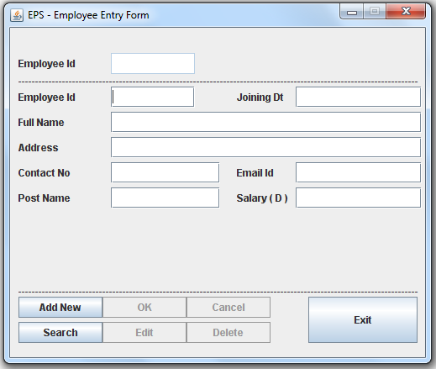

**Employee Report:**

**Login Form:**

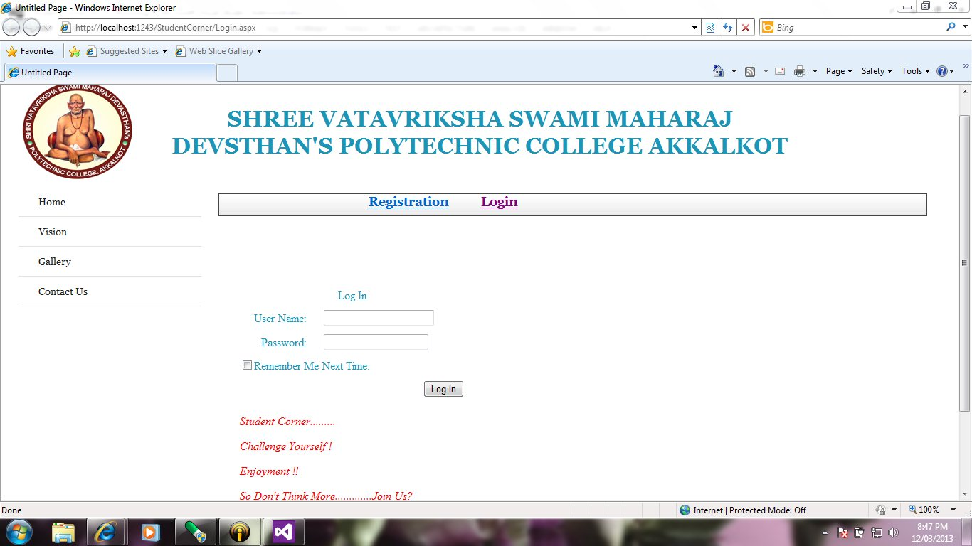

**Question Paper:**

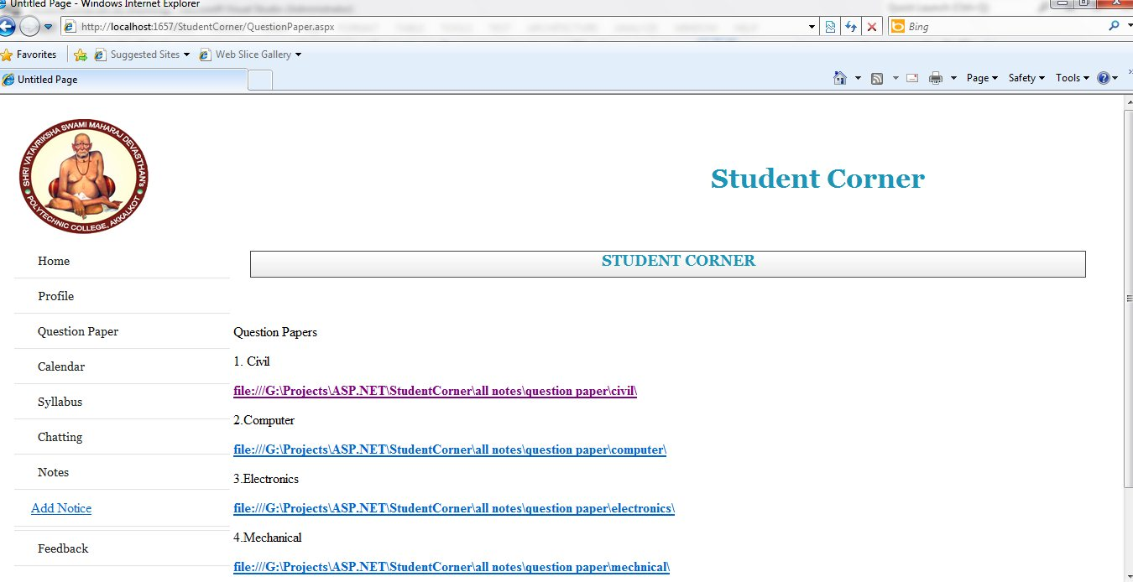

**Academic Calendar:**

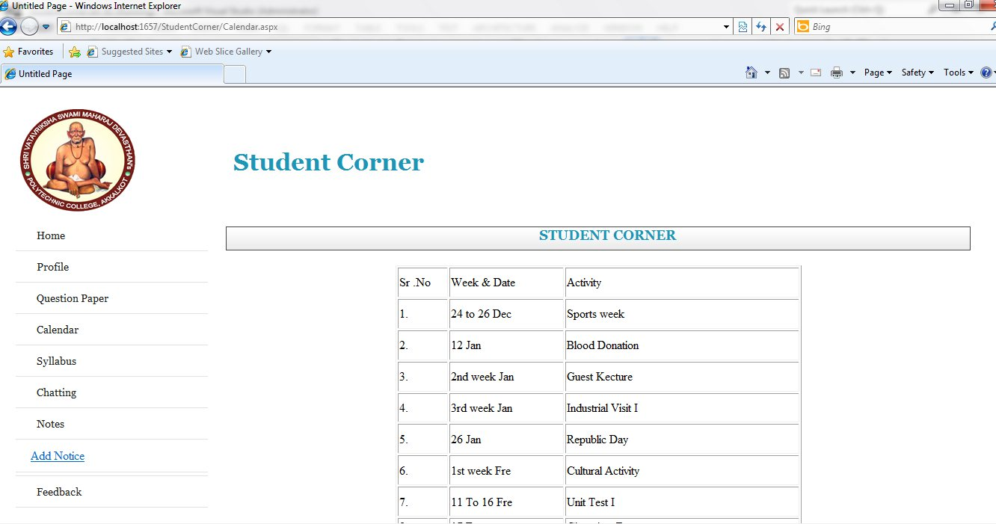

**Syllabus:**

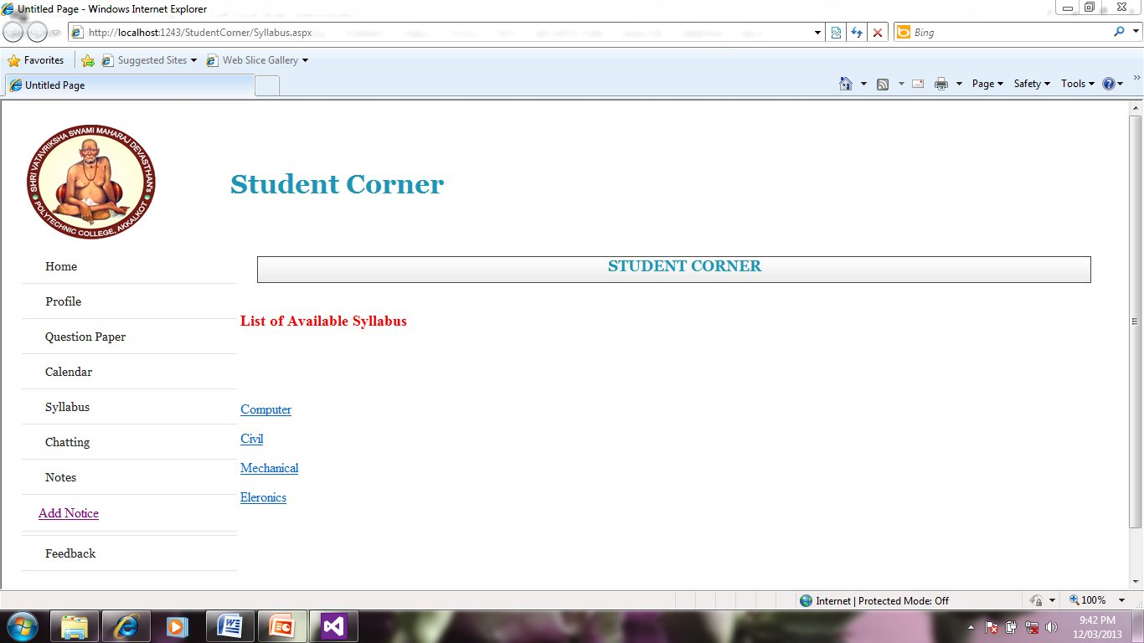

**All Notes:**

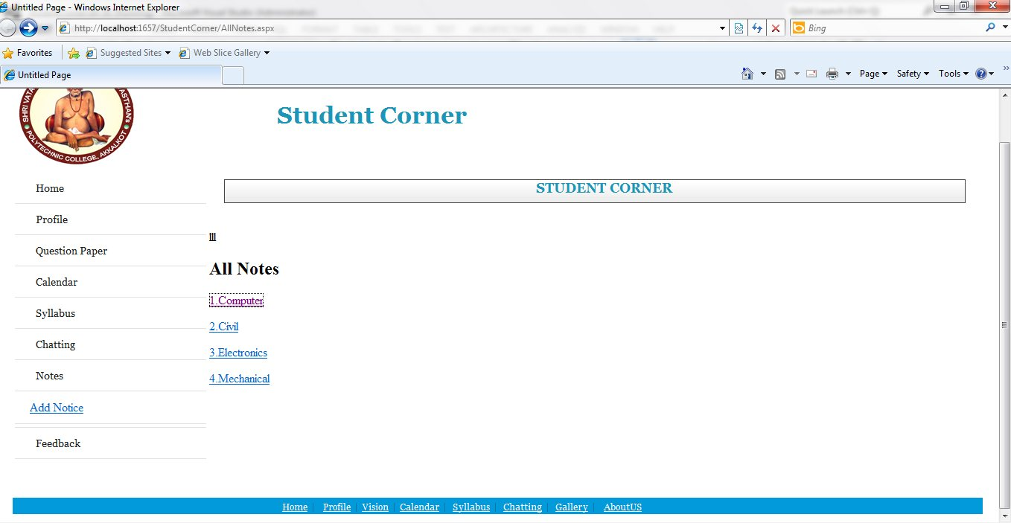

**Computer Department Notes:**

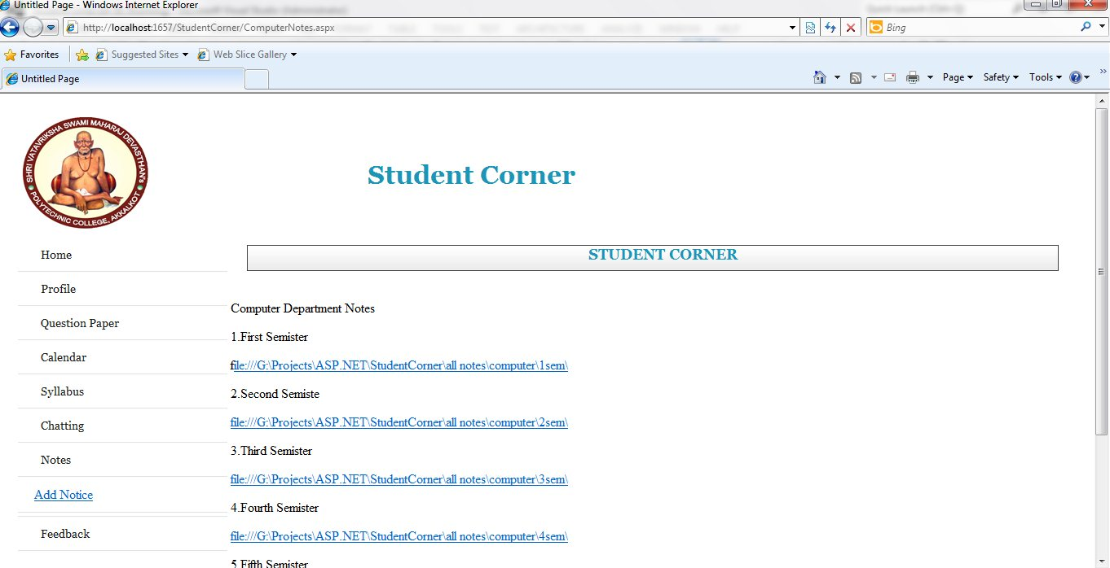

**Notice:**

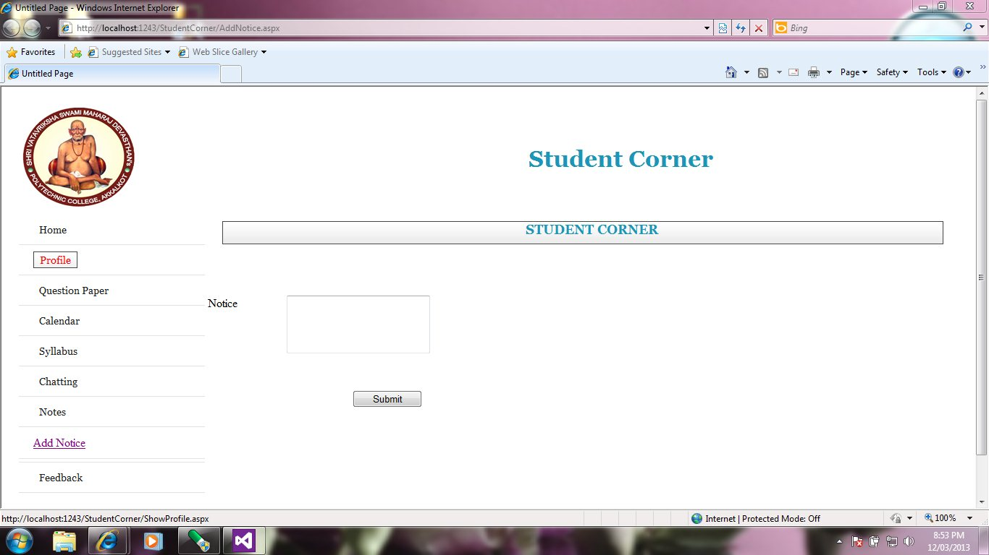

**Chatting Form:**

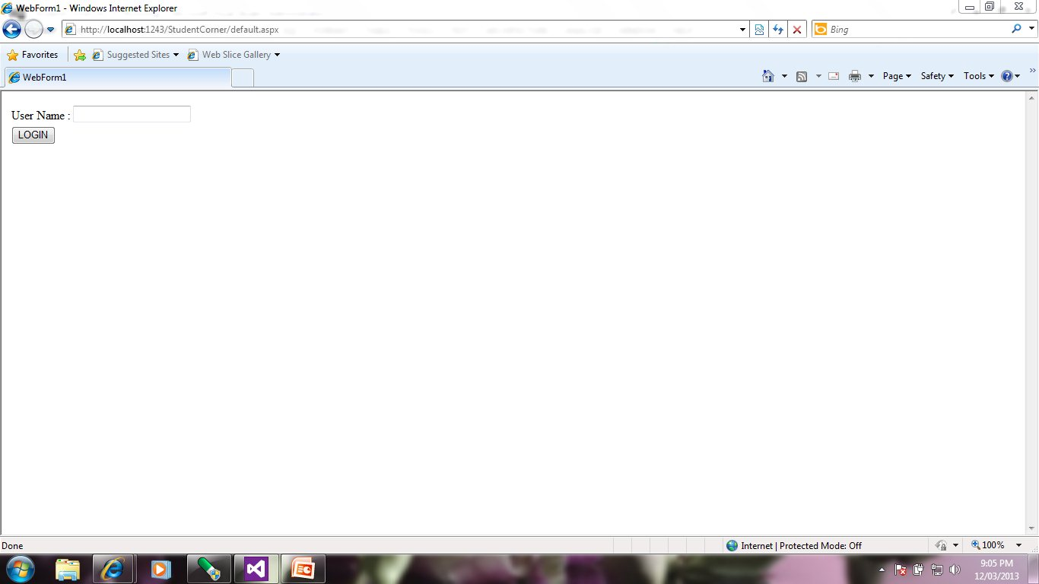

**User Name With Whom You Want To Chat:**

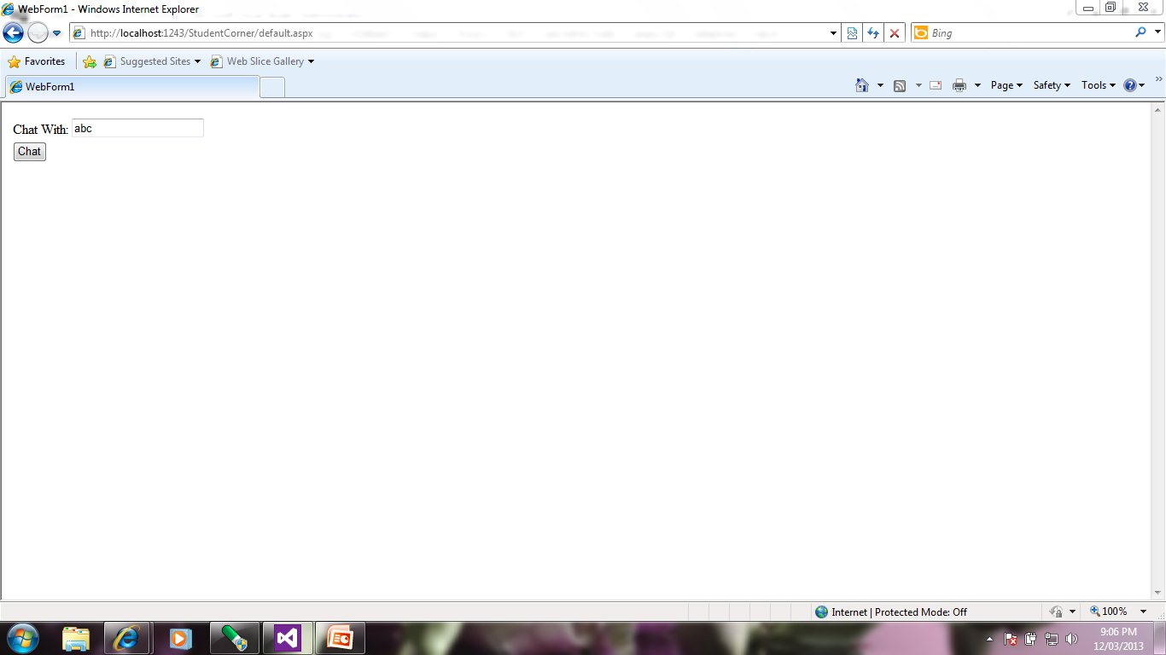

**Sending Message**:

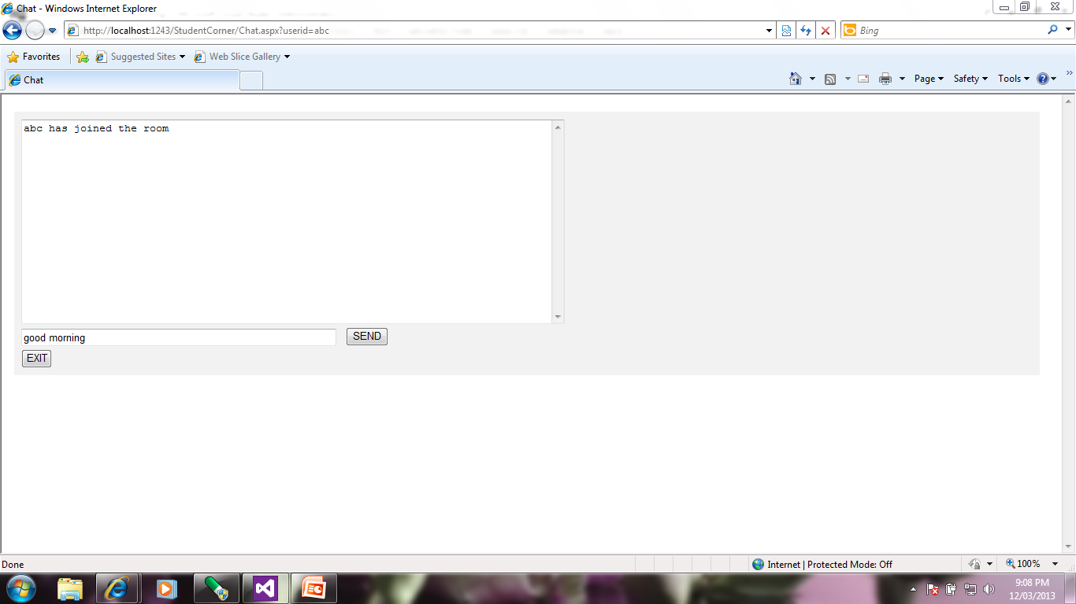

**Feedback Form:**

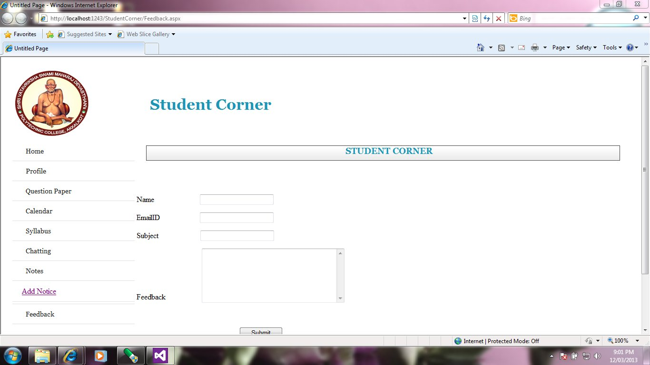

**ADVANTAGES:**

* Time saving.
* More information is available.
* Important notification
* Friend circle is created
* Detail knowledge is acquired

**APPLICATION:**

This project can be used in various Education field that one help to students to get more knowledge. Sometimes students don’t like to read books, so he/she may access this website for study. In some university or colleges notes are not provided. And at the time of exam student needs question paper and syllabus, in such a cases it is very useful to do proper study.

Some of Applications are:

* University
* Colleges
* Organization
* Institute

**FUTURE SCOPE**

In future we are providing extra functionality to the student such as, they can post their own poem or article. In case of parent’s meeting we need to send letter to student’s home but it is so much

time consuming. And don’t guarantee that proper delivery of letter. So we are providing extra facility

to all HOD to send message from computer to student’s mobile informing that the meeting is

conducted. Sending message take place under control of principal i.e. we are providing security.

In your application two students can chat with each other. So number of student chatting with each

other will be increases.

**CONCLUSION**

Some institute’s web sites show the only institute information, course information. They were not providing any type of online help for the students. As per students requirements ‘**Student Corner’** web application is developed. The ‘Student Corner’ web site provides each and every information and also online help for students. It gives unique registration with unique enrollment id to the student that is very useful. The purpose of creating this web site is solving student’s problem.

This web site provide some functionality as like students view their Profile, Study Material, Notices, Academic Calendar, chatting & also they gives feedback etc. So, adding various new functionality, this site is providing some knowledge to get to know the idea of how it works better

**REFERENCES**

**Website References:-**

[**www.w3schools.com**](http://www.w3schools.com)

[**www.pageresource.com**](http://www.pageresource.com)

[**www.svsmd.com**](http://www.svsmd.com)

**www.msbte.com**

**Book References:-**

HTML complete reference

Practical ASP - by Ivan Bayross

ASP.NET-by Bill Evjen